Programming Languages

💻 What are Programming Languages?
# Source: AI Source: Provided by: [Data Path: Persons Table -> ID Column: 1, Name_En Column: Motasem Essam] -> From: [Chatgpt (GPT‑5 Mini)] on [12/9/2025]
A programming language is a formal language used to write instructions that a computer can understand and execute.

📌 Simple definition:
# Source: AI Source: Provided by: [Data Path: Persons Table -> ID Column: 1, Name_En Column: Motasem Essam] -> From: [Chatgpt (GPT‑5 Mini)] on [12/9/2025]
Programming Language = A way to tell a computer what to do.

🧠 Key idea:
# Source: AI Source: Provided by: [Data Path: Persons Table -> ID Column: 1, Name_En Column: Motasem Essam] -> From: [Chatgpt (GPT‑5 Mini)] on [12/9/2025]
You write code → the computer runs it → you get a result

🔍 Main characteristics:
# Source: AI Source: Provided by: [Data Path: Persons Table -> ID Column: 1, Name_En Column: Motasem Essam] -> From: [Chatgpt (GPT‑5 Mini)] on [12/9/2025]
- ✅ Has strict rules (syntax)
- ✅ Has meaning (semantics)
- ✅ Used to create programs, apps, systems
- ✅ Can be translated into machine code (by a compiler or interpreter)

🧩 Examples:
# Source: AI Source: Provided by: [Data Path: Persons Table -> ID Column: 1, Name_En Column: Motasem Essam] -> From: [Chatgpt (GPT‑5 Mini)] on [12/9/2025]
- Python 🐍
- Java ☕
- C++
- JavaScript 🌐

⚙️ What can you do with them?
# Source: AI Source: Provided by: [Data Path: Persons Table -> ID Column: 1, Name_En Column: Motasem Essam] -> From: [Chatgpt (GPT‑5 Mini)] on [12/9/2025]
- Build websites 🌍
- Create mobile apps 📱
- Develop games 🎮
- Automate tasks 🤖
- Work with data 📊

🧱 Types (simplified):
# Source: AI Source: Provided by: [Data Path: Persons Table -> ID Column: 1, Name_En Column: Motasem Essam] -> From: [Chatgpt (GPT‑5 Mini)] on [12/9/2025]
1. High-level languages
- Easy for humans
- Example: Python
2. Low-level languages
- Closer to machine
- Example: Assembly

🔄 How they work:
# Source: AI Source: Provided by: [Data Path: Persons Table -> ID Column: 1, Name_En Column: Motasem Essam] -> From: [Chatgpt (GPT‑5 Mini)] on [12/9/2025]
- You write code
- A compiler or interpreter translates it
- Computer executes it

🆚 Programming vs Other Languages
# Source: AI Source: Provided by: [Data Path: Persons Table -> ID Column: 1, Name_En Column: Motasem Essam] -> From: [Chatgpt (GPT‑5 Mini)] on [12/9/2025]
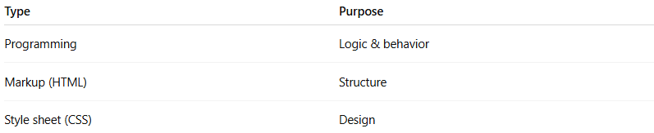
Type | Purpose
Programming | Logic & behavior
Markup (HTML) | Structure
Style sheet (CSS) | Design

✅ Summary:
# Source: AI Source: Provided by: [Data Path: Persons Table -> ID Column: 1, Name_En Column: Motasem Essam] -> From: [Chatgpt (GPT‑5 Mini)] on [12/9/2025]
Programming languages are the tools we use to build software and control computers using precise, rule-based instructions.

